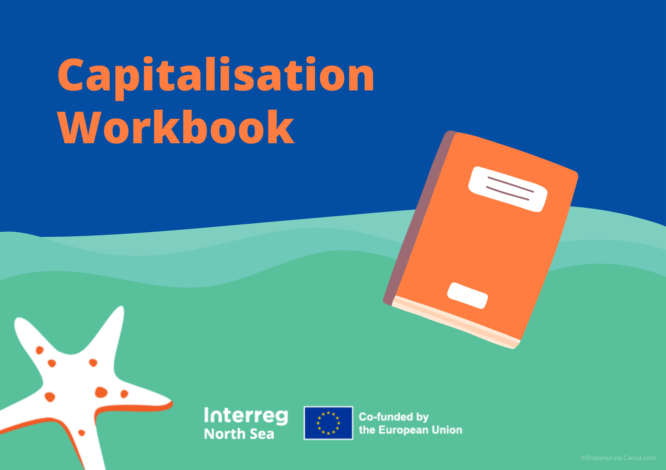

THE 7 ESSENTIALS ESSENTIALS

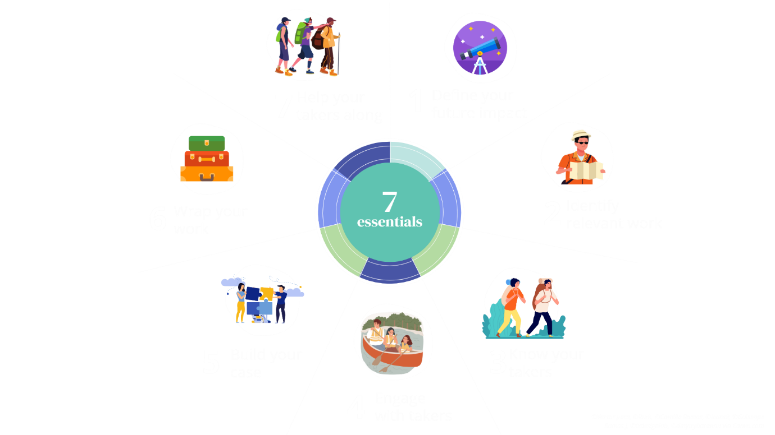

THE 7 ESSENTIALS

Exercise 1. Impact challenge

PART 1A. LIST YOUR MAIN 1-3 IMPACTS

1 | Please list your main expected 1-3 impacts
2 | Why is capitalisation important for your project?

PART 1B. For each impact (positive change) listed in Part A, fill in the table below.

POSITIVE CHANGE* | Describe the impact
HOW* | Describe what you will do to create that positive change.
TAKERS | Those groups who will adopt and reuse the work that leads to the positive change.
END USERS | Those that will ultimately benefit from the positive change.
SCALE | Figures for the scale of the positive change you will create during or after your project.
WHEN | Timeframe for when the positive change will happen.
*Mandatory elements
STEP 2: Develop an impact statement using the first two (mandatory) elements:
STEP 3: Try improving your statement by adding one or more of the last four (optional) elements:

Exercise 2. Identify relevant work

Please list specific products that can be transferred, replicated, and/or scaled up (strategies, action plans, and pilot actions / solutions such as tools, techniques, policy briefs, etc.) | Impact level  1 (low) - 5 (high)

Exercise 3. Know your takers

Product  Enter your top priority project from Exercise 2 | Takers  For example, public sector agencies | Taker sub-groups  For example, specific roles or departments | What do you know about them?  What are their goals and priorities?  What are their challenges and frustrations?  How and where do they get their info?  What kind of budget do they have?  What makes them happy? | Why would they care about the product? What’s in it for them?  Would your product help them with their own goals and agendas?

Exercise 4. Engage with your takers

Takers | Best ways to reach and engage with takers | Multipliers who can reach more takers | Ways to engage multipliers
 | .

Exercise 5. Build your case
Product | Takers | What would convince takers to adopt your work? Consider the barriers and how to overcome them.
 |  | .

Exercise 6. Wrap your work
Product | Takers | Key communication products & actions
 | .

Exercise 7. Help your takers along
Product | Takers | Challenge / barrier | How to help the takers past the challenge
 | .

Exercise 8. Create a road map

 | Action | Time | Responsible
1
2
3
4
5
6
7
8
9
10

